Magnitude Baseline Shifter Plug-In
This observation transformation plug-in shifts the observations in one or more series by the specified amount and is accessible from the Tool menu:
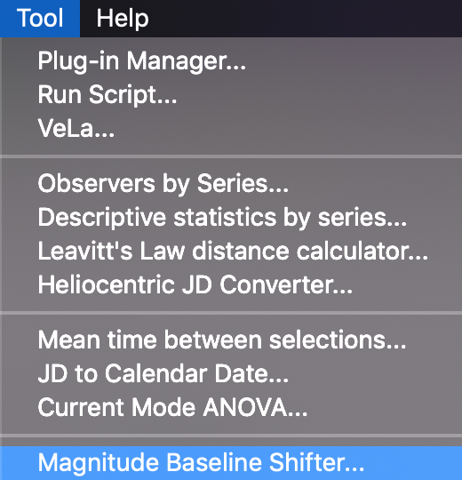
In the following example, visual and Johnson V eta Aql observations have been loaded and a phase plot created. The plug-in has been selected from the Tool menu and the Johnson V series selected in the dialog that opens.
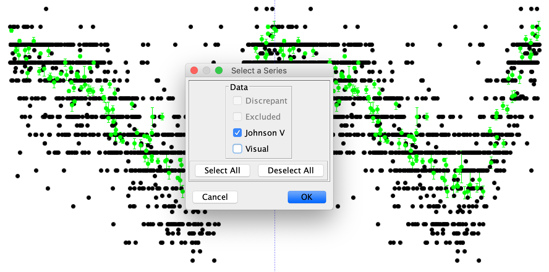
Clicking the OK button yields another dialog, requesting the amount to shift by which can be positive or negative:
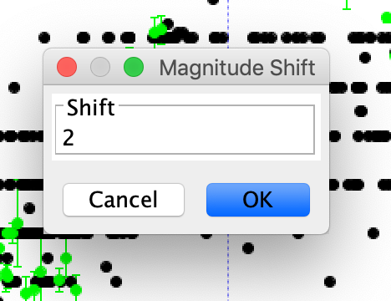
Entering a number, 2 here, and clicking the OK button adds 2 to all Johnson V observations.
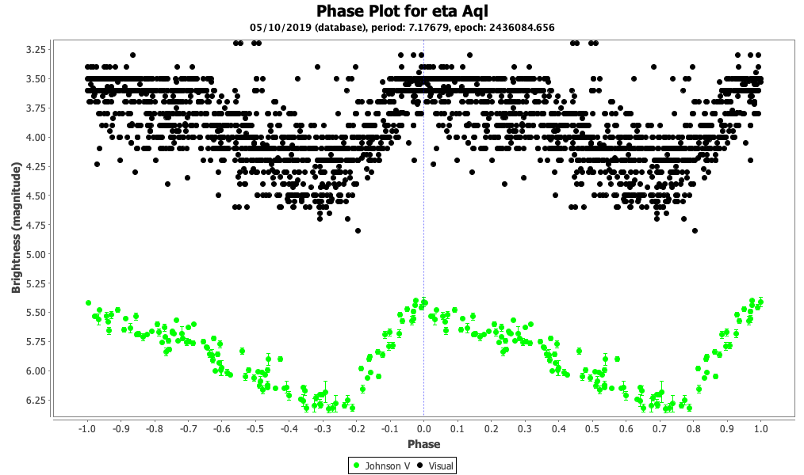
Selecting Undo from the Edit menu undoes this operation:
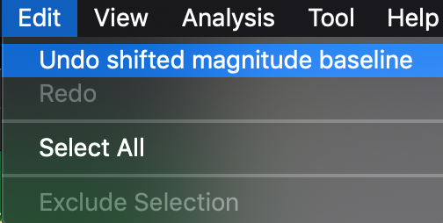
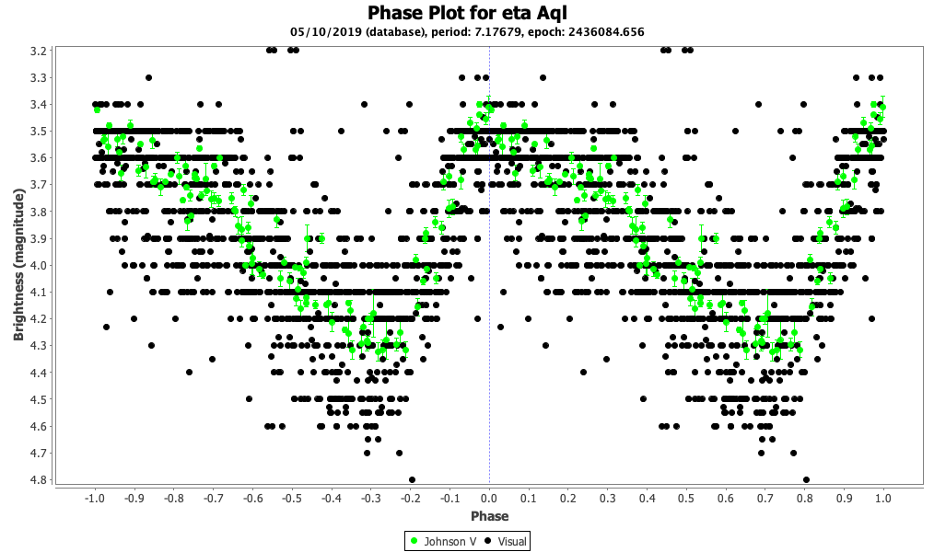
Selecting Redo from the Edit menu applies the original operation again.
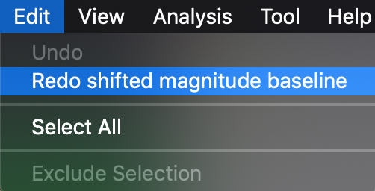
This undo/redo cycle can be repeated.
Using the plug-in again for a new magnitude shift operation starts a new undo/redo cycle.

